**English I AAC Summer Reading Book List**

**Option 1: *The Naturals,* by Jennifer Lynn Barnes**

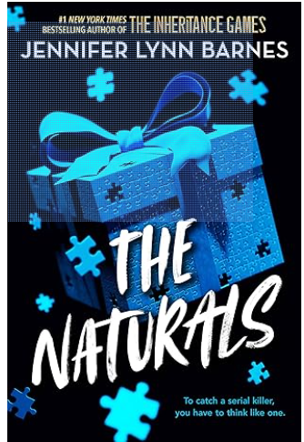

***Don’t miss this exhilarating crime thriller—perfect for fans of Criminal Minds and A Good Girl’s Guide to Murder—from Jennifer Lynn Barnes, the #1 New York Times bestselling author of The Inheritance Games.***Seventeen-year-old Cassie is a natural at reading people, piecing together the tiniest details to know who a person is and what they want. But it’s not a skill she takes seriously until the FBI come knocking—they’ve begun a classified program that uses exceptional teens to crack infamous cold cases, and they want her to join.  
  
But there’s more at risk than a few unsolved homicides. Sent to live with a group of teens whose gifts are as unusual as her own, Cassie quickly realizes no one in the Naturals program is what they seem. Emotion-reader Michael is a wild card—and far too perceptive for Cassie’s good. The resident deception-detector is a pathological liar, and the program’s perky, blonde statistician is far better with numbers than with people. And then there’s Dean—a profiler like Cassie but with a much darker gift.  
When a new killer strikes, danger looms close. Caught in a lethal game of cat and mouse with a killer, the Naturals are going to have to use all of their gifts just to survive.**NOTE: *The Naturals* presents a serial killer's point of view. There is some violence and portrayal of murders. There are characters that are shot, stabbed, and killed, but this title is meant for YA (teens). Do not select this title if you (or parents) are not comfortable with it.**

**Option 2: *We Were Liars*, by E. Lockhart**

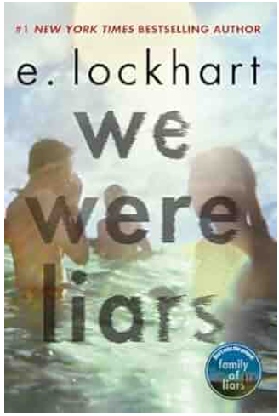

**#1 *NEW YORK TIMES* BESTSELLER • A *KIRKUS REVIEWS* BEST YOUNG ADULT BOOK OF THE CENTURY   
  
*"Thrilling, beautiful, and blisteringly smart, We Were Liars is utterly unforgettable." —John Green, #1 New York Times bestselling author of The Fault in Our Stars***A beautiful and distinguished family.  
A private island.  
A brilliant, damaged girl; a passionate, political boy.  
A group of four friends—the Liars—whose friendship turns destructive.  
A revolution. An accident. A secret.  
Lies upon lies.  
The truth.  
Read it.  
And if anyone asks you how it ends, just LIE.

**Option 3: *The Inheritance Games*, by Jennifer Lynn Barnes**

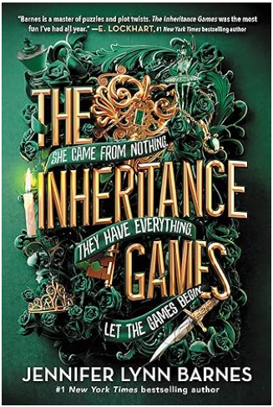

From Amazon: **Don't miss this *New York Times* bestselling "impossible to put down" (Buzzfeed) novel with deadly stakes, thrilling twists, and juicy secrets—perfect for fans of *One of Us is Lying* and *Knives Out*.**Avery Grambs has a plan for a better future: survive high school, win a scholarship, and get out. But her fortunes change in an instant when billionaire Tobias Hawthorne dies and leaves Avery virtually his entire fortune. The catch? Avery has no idea why—or even who Tobias Hawthorne is.  
  
To receive her inheritance, Avery must move into sprawling, secret passage-filled Hawthorne House, where every room bears the old man's touch—and his love of puzzles, riddles, and codes. Unfortunately for Avery, Hawthorne House is also occupied by the family that Tobias Hawthorne just dispossessed. This includes the four Hawthorne grandsons: dangerous, magnetic, brilliant boys who grew up with every expectation that one day, they would inherit billions. Heir apparent Grayson Hawthorne is convinced that Avery must be a conwoman, and he's determined to take her down. His brother, Jameson, views her as their grandfather's last hurrah: a twisted riddle, a puzzle to be solved. Caught in a world of wealth and privilege with danger around every turn, Avery will have to play the game herself just to survive.

**Option 4: *Truly Devious*, by Maureen Johnson**

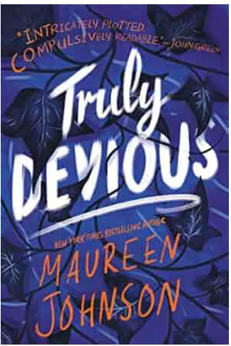

***New York Times*bestselling author Maureen Johnson weaves a delicate tale of murder and mystery in the first book of a striking new series, perfect for fans of Agatha Christie and E. Lockhart.**

Ellingham Academy is a famous private school in Vermont for the brightest thinkers, inventors, and artists. It was founded by Albert Ellingham, an early twentieth century tycoon, who wanted to make a wonderful place full of riddles, twisting pathways, and gardens. “A place,” he said, “where learning is a game.”

Shortly after the school opened, his wife and daughter were kidnapped. The only real clue was a mocking riddle listing methods of murder, signed with the frightening pseudonym “Truly, Devious.” It became one of the great unsolved crimes of American history.

True-crime aficionado Stevie Bell is set to begin her first year at Ellingham Academy, and she has an ambitious plan: She will solve this cold case. That is, she will solve the case when she gets a grip on her demanding new school life and her housemates: the inventor, the novelist, the actor, the artist, and the jokester.

But something strange is happening. Truly Devious makes a surprise return, and death revisits Ellingham Academy. The past has crawled out of its grave. Someone has gotten away with murder.